Mom and Pop Johnson Video Shop

Sairam Soundararajan

CMIS 320

Professor Liu

University of Maryland Global Campus

November 15th, 2022

**Snapshot of Entity Relationship Diagram from ERAssistant**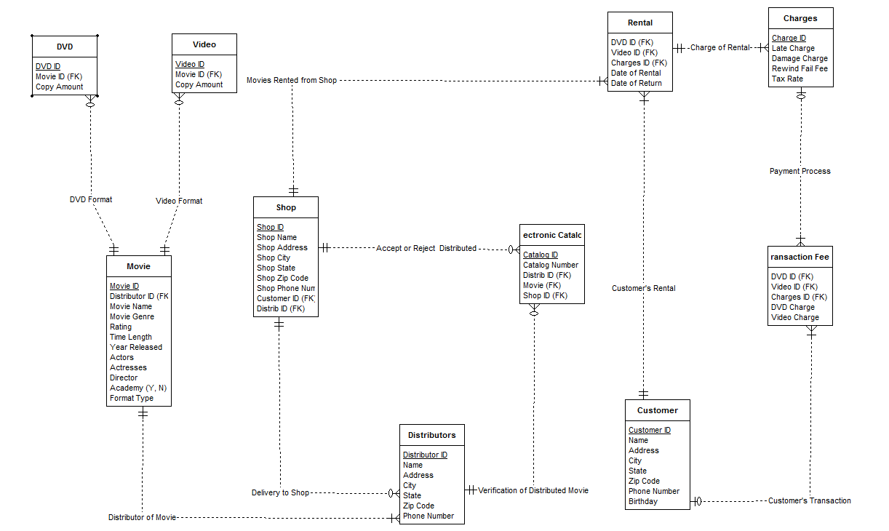

**Metadata**

|  |  |  |  |  |
| --- | --- | --- | --- | --- |
| **Example (starter) Meta Data** |  |  |  |  |
| **Mom & Pop Database** | | | | |
|  |  |  |  |  |
| **Entity Name** | **Attributes** | **PK/FK?** | **Data Type** | **Description** |
| **DVD** | ***ID*** | PK | integer | Primary Key for DVD Entity |
|  | ***Movie ID*** | FK | integer | Foreign Key for DVD Entity |
|  | Copy Amount | no | int | Number of DVD copies |
| **Video** | ***ID*** | PK | integer | Primary Key for Video Entity |
|  | ***Movie ID*** | FK | integer | Foreign Key for Video Entity |
|  | Copy Amount | no | varchar (255) | Number of Video copies |
| **Movie** | ***ID*** | PK | int | Primary key for Movie |

|  |  |  |  |  |
| --- | --- | --- | --- | --- |
|  | ***DistributorID*** | FK | int | This is the FK that points to Distributor |
|  | Movie Name | no | varchar (255) | Title of Movie |
|  | Movie Genre | No | varchar (20) | Genre of Movie |
|  | Time Length | no | int | Length of Movie |
|  | Rating | no | char(1) | Customer rating of Movie |
|  | Year Released | no | int | Year of Release |
|  | Actors | no | varchar (255) | Actors of Movie |
|  | Actresses | no | varchar (255) | Actresses of Movie |
|  | Director | no | varchar(255) | Director of Movie |
|  | Academy (Y, N) | no | boolean | Did the movie/actors win academy award |
|  | Format Type | no | varchar(10) | Is the movie on DVD or VHS |
| **Distributors** | ***ID*** | PK | int | Primary key for Distributor |
|  | Name | no | varchar(255) | Name of Distributor |
|  | Address | no | varchar(30) | Distributor(s) Address |
|  | City | no | varchar(30) | Distributor(s) City |
|  | State | no | varchar(3) | Distributor(s) State |
|  | Zip Code | no | int | Distributor(s) Zip Code |
|  | Phone Number | no | varchar(11) | Distributor(s) Phone Number (no dashes) |
| **Electronic Catalog** | ***ID*** | PK | int | Primary key for catalog |
|  | Catalog Number | no | int | Number Identification for catalog |
|  | Distrib ID (FK) | FK | int | Foreign key for Distributors ID |
|  | Movie (FK) | FK | int | Foreign key for Movie |
|  | Shop ID (FK) | FK | int | Foreign key for Video Store ID |
| **Rental** | DVD ID (FK) | FK | int | Foreign key for DVD |
|  | Video ID (FK) | FK | int | Foreign key for Video/VHS |
|  | Charges ID (FK) | FK | int | Foreign key for fees |
|  | Date of Rental | no | date | Rental date for Movie |
|  | Date of Return | no | date | Date in which movie was returned |
| **Charges** | ***ID*** | PK | int | Primary key for fee |
|  | Late Charge | no | double | Cost of late return for movie |
|  | Damage Charge | no | double | Cost of damage on rental |
|  | Rewind Fail Fee | no | double | Cost of rewind failure on rental |
|  | Tax Rate | no | double | Cost on tax on rental |
| **Transaction Fees** | DVD ID (FK) | FK | int | Foreign key for DVD |
|  | Video ID (FK) | FK | int | Foreign key for Video |
|  | Charges ID (FK) | FK | int | Foreign key for fees |
|  | DVD Charge | no | double | Cost of DVD |
|  | Video Charge | no | double | Cost of Video/VHS |
| **Shop** | ***ID*** | PK | int | Primary key for Store ID |
|  | Shop Name | no | varchar(255) | Name of Store |
|  | Shop Address | no | varchar(255) | Street Address of Store |
|  | Shop City | no | varchar(255) | City of Store |
|  | Shop State | no | varchar(255) | State of Store |
|  | Shop Zip Code | no | int | Zip Code of Store |
|  | Shop Phone Num | no | varchar(11) | Store telephone number (no dashes) |
|  | Customer ID (FK) | FK | int | Foreign key for customer ID number |
|  | Distrib ID (FK) | FK | int | Foreign key for distribution |
| **Customer** | ***ID*** | PK | int | Primary key for customer |
|  | Name | no | varchar(255) | Name of Customer |
|  | Address | no | varchar(255) | Customer’s street address |
|  | City | no | varchar(255) | Customer’s city of home address |
|  | State | no | varchar(3) | Customer’s state of home address |
|  | Zip Code | no | int | Customer’s zip code of home address |
|  | Phone Number | no | varchar() | Customer’s phone number (no dashes) |
|  | Birthday | no | date | Customer’s birthday (mm/dd/yyyy) |